Linux Shell or terminal:
So, basically, a shell is a program that receives commands from the user and gives it to the OS to process, and it shows the output. Linux's shell is its main part. Its distros come in GUI (graphical user interface), but basically, Linux has a CLI (command line interface).

To open the terminal, press Ctrl+Alt+T in Ubuntu, or press Alt+F2, type in gnome-terminal, and press enter.

Basic Linux commands and uses:

1. pwd — When you first open the terminal, you are in the home directory of your user. To know which directory you are in, you can use the “pwd” command. It gives us the absolute path, which means the path that starts from the root. The root is the base of the Linux file system. It is denoted by a forward slash( / ). The user directory is usually something like "/home/username".
2. ls — Use the "ls" command to know what files are in the directory you are in. You can see all the hidden files by using the command “ls -a”.
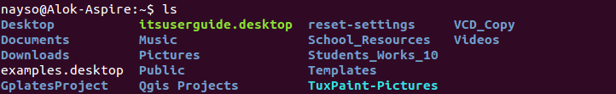
3. cd — Use the "cd" command to go to a directory. For example, if you are in the home folder, and you want to go to the downloads folder, then you can type in“cd Downloads”. Remember, this command is case sensitive, and you have to type in the name of the folder exactly as it is. But there is a problem with these commands. Imagine you have a folder named “Raspberry Pi”. In this case, when you type in “cd Raspberry Pi”, the shell will take the second argument of the command as a different one, so you will get an error saying that the directory does not exist. Here, you can use a backward slash. That is, you can use “cd Raspberry\ Pi” in this case. Spaces are denoted like this: If you just type “cd”and press enter, it takes you to the home directory. To go back from a folder to the folder before that, you can type “cd ..” . The two dots represent back.


4. mkdir & rmdir — Use the mkdir command when you need to create a folder or a directory. For example, if you want to make a directory called “DIY”, then you can type “mkdir DIY”. Remember, as told before, if you want to create a directory named “DIY Hacking”, then you can type “mkdir DIY\ Hacking”. Use rmdir to delete a directory. But rmdir can only be used to delete an empty directory. To delete a directory containing files, use rm.
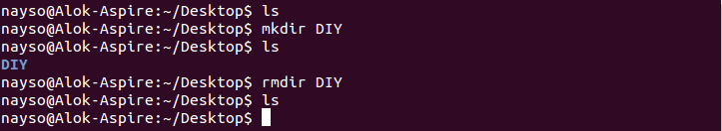
5. rm - Use the rm command to delete files and directories. Use "rm -r" to delete just the directory. It deletes both the folder and the files it contains when using only the rm command.
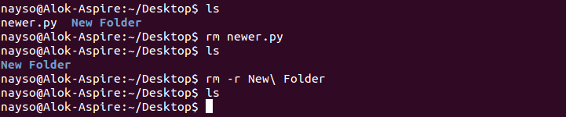
6. touch — The touch command is used to create a file. It can be anything, from an empty txt file to an empty zip file. For example, “touch new.txt”.


7. man & --help — To know more about a command and how to use it, use the man command. It shows the manual pages of the command. For example, “man cd” shows the manual pages of the cd command. Typing in the command name and the argument helps it show which ways the command can be used (e.g., cd –help).
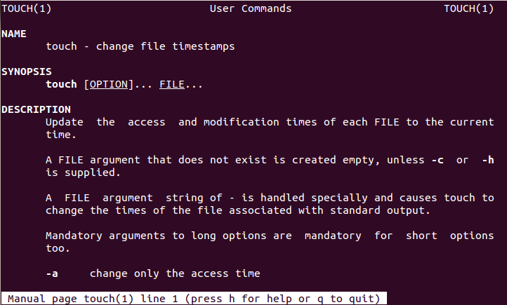8. cp — Use the cp command to copy files through the command line. It takes two arguments: The first is the location of the file to be copied, the second is where to copy.


9. mv — Use the mv command to move files through the command line. We can also use the mv command to rename a file. For example, if we want to rename the file “text” to “new”, we can use “mv text new”. It takes the two arguments, just like the cp command.

10. locate — The locate command is used to locate a file in a Linux system, just like the search command in Windows. This command is useful when you don't know where a file is saved or the actual name of the file. Using the -i argument with the command helps to ignore the case (it doesn't matter if it is uppercase or lowercase). So, if you want a file that has the word “hello”, it gives the list of all the files in your Linux system containing the word "hello" when you type in “locate -i hello”. If you remember two words, you can separate them using an asterisk (*). For example, to locate a file containing the words "hello" and "this", you can use the command “locate -i *hello*this”.
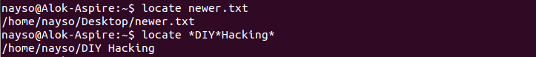
11. echo — The "echo" command helps us move some data, usually text into a file. For example, if you want to create a new text file or add to an already made text file, you just need to type in, “echo hello, my name is alok >> new.txt”. You do not need to separate the spaces by using the backward slash here, because we put in two triangular brackets when we finish what we need to write.
12. cat — Use the cat command to display the contents of a file. It is usually used to easily view programs.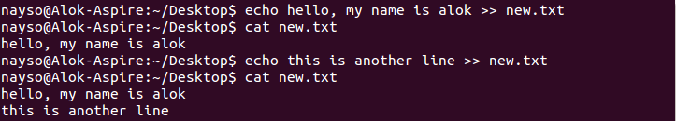
13. sudo — A widely used command in the Linux command line, sudo stands for "SuperUser Do". So, if you want any command to be done with administrative or root privileges, you can use the sudo command. For example, if you want to edit a file like viz. alsa-base.conf, which needs root permissions, you can use the command – sudo nano alsa-base.conf. You can enter the root command line using the command “sudo bash”, then type in your user password. You can also use the command “su” to do this, but you need to set a root password before that. For that, you can use the command “sudo passwd”(not misspelled, it is passwd). Then type in the new root password.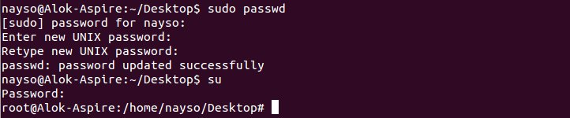
14. apt-get — Use apt to work with packages in the Linux command line. Use apt-get to install packages. This requires root privileges, so use the sudocommand with it. For example, if you want to install the text editor jed (as I mentioned earlier), we can type in the command “sudo apt-get install jed”. Similarly, any packages can be installed like this. It is good to update your repository each time you try to install a new package. You can do that by typing “sudo apt-get update”. You can upgrade the system by typing “sudo apt-get upgrade”. We can also upgrade the distro by typing “sudo apt-get dist-upgrade”. The command “apt-cache search” is used to search for a package. If you want to search for one, you can type in “apt-cache search jed”(this doesn't require root).

15 ping — Use ping to check your connection to a server. Wikipedia says, "Pingis a computer network administration software utility used to test the reachability of a host on an Internet Protocol (IP) network". Simply, when you type in, for example, “ping google.com”, it checks if it can connect to the server and come back. It measures this round-trip time and gives you the details about it. The use of this command for simple users like us is to check your internet connection. If it pings the Google server (in this case), you can confirm that your internet connection is active!
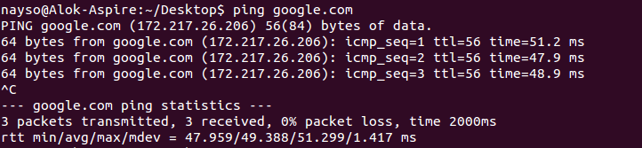

Submitted By:
Md Rasel
IT-17049

